SR UNIVERSITY
AI ASSISSTED CODING
LAB-TEST-IV
NAME:P.Susmija
Roll No:2503A51L11
TASK-1:
Q1:Data Cleaning:
- Supply noisy sensor data; generate AI-suggested smoothing and outlier removal code.

CODE Generated:
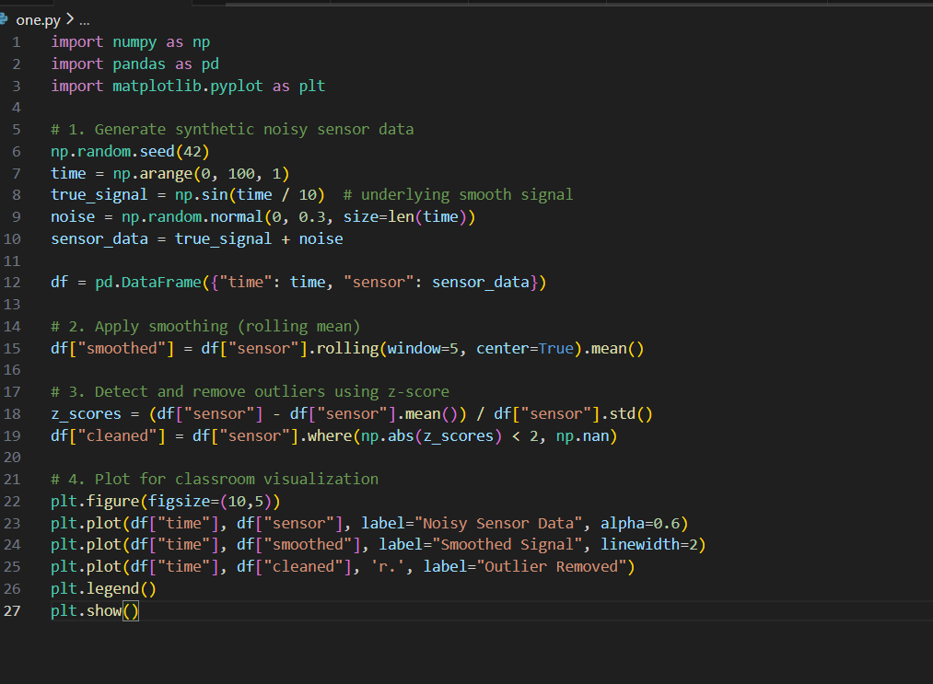
OUTPUT:
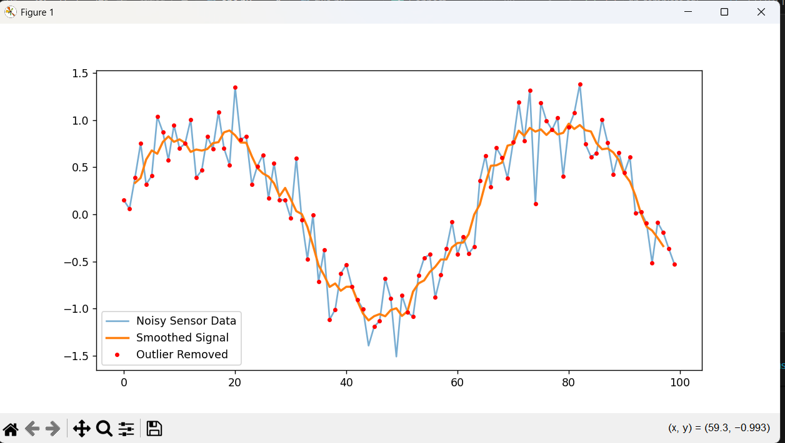
Observations:
Raw Data: The sensor readings fluctuate heavily due to random noise, making the underlying sinusoidal pattern hard to see.
Smoothing (Rolling Mean):
- The rolling average reduces short-term fluctuations.
- The sinusoidal trend becomes more visible, though extreme smoothing (large window size) can distort peaks and valleys.
Outlier Removal (Z-score):
- Outliers beyond ±2 standard deviations are replaced with NaN.
- This prevents extreme values from skewing analysis.
- Students will notice red dots disappear where noise was unusually high or low.

b.Generate a script to handle missing temperature values using interpolation
CODE GENERATED:
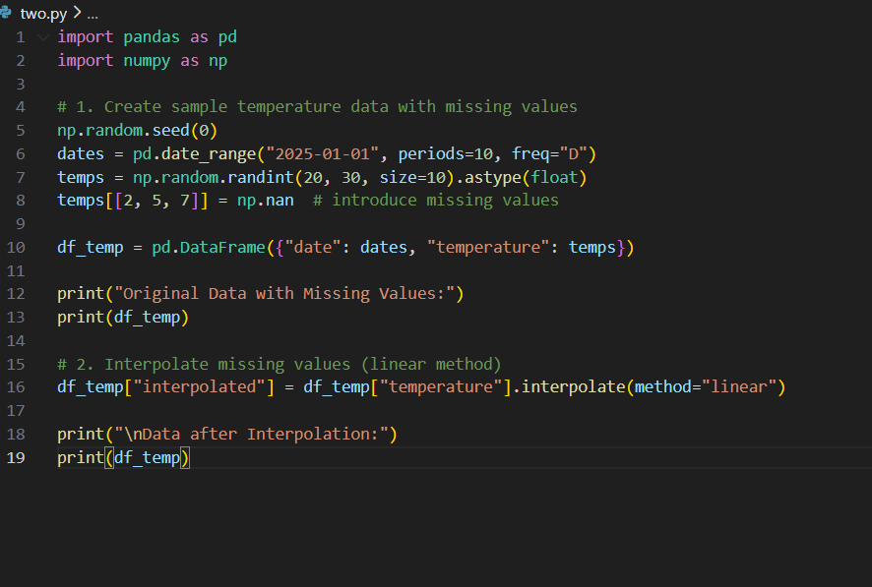
OUTPUT:
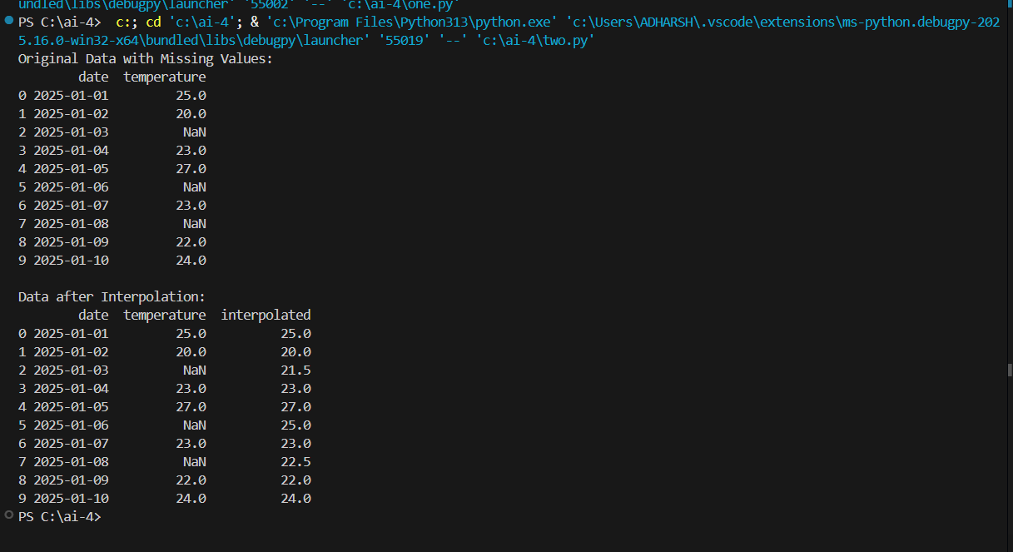
Observation:
Original Data: Missing values (NaN) break continuity and prevent direct statistical analysis.
Linear Interpolation:
- Missing values are filled by estimating between neighboring points.
- The filled values follow a straight line between known temperatures.
Effectiveness:
- Restores continuity in the dataset.
- Preserves overall trend without introducing unrealistic jumps.
  - 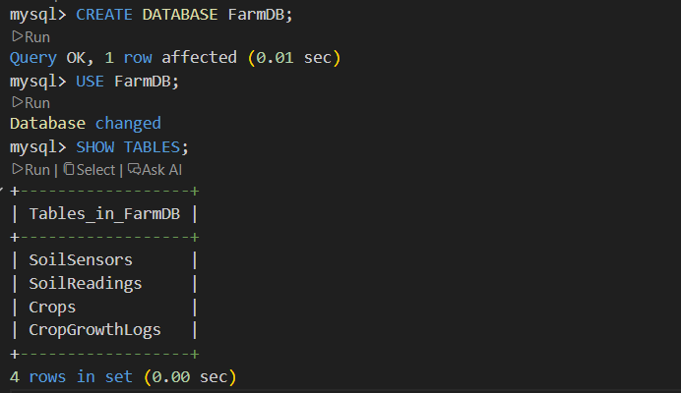
Key Insight: Interpolation is most effective when missing gaps are small; large gaps may require domain-specific modeling.

TASK-2:
Q2. Database Design
a. Use AI to design a schema for Soil Sensors and Crop Growth Logs.
b. Generate SQL queries for weekly yield predictions
1.Inserting values:
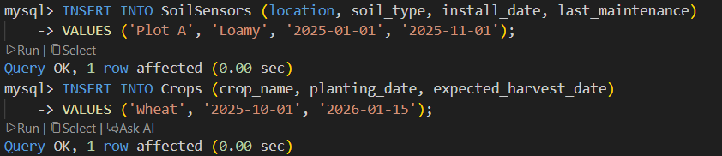
2.Weekly yield aggregation:
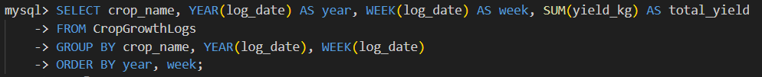
3.Average weekly yield:
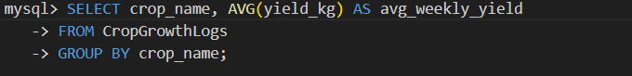
OBSERVATIONS:
Normalization:
- Sensor metadata (location, soil type, install date) is separated from sensor readings.
- Crop metadata (planting/harvest dates) is separated from growth logs.
Scalability:
  - New sensors or crops can be added without altering the schema.
Weekly Aggregation:
- The query groups yields by crop and week, showing total production per week.
- Useful for monitoring short-term performance and identifying peak weeks.
Average Weekly Yield:
Provides a baseline prediction for future weeks.
Students will notice that averages smooth out fluctuations but may miss sudden changes.
Prediction Query:
  - Uses historical averages to estimate next week’s yield.

